**ONLINE RETAIL**

**SEGMENTATION**

DATA MINING FINAL PROJECT

**Presented by**

# AFTAB NAFEES

# **GitHub Username**

# aftab1038

# **Repository Link**

# https://shorturl.at/5tZOf

**Table of Contents**

Introduction 03

Beginner Queries 04

Metadata Definition 04

Distribution of Order Values 05

Unique Products Purchased 06

Single Purchase Customers 07

Commonly Purchased Products Together 08

Advance Queries 09

Customer Segmentation by Purchase Frequency 09

Average Order Value by Country 10

Customer Churn Analysis 11

Product Affinity Analysis 12

Time-based Analysis 13

Conclusion 14

**Introduction**

The objective of this project is to perform customer segmentation using data mining techniques, specifically through SQL. Customer segmentation allows businesses to categorize clients based on various factors such as demographics and purchasing patterns. This segmentation is crucial for tailoring marketing strategies, improving customer satisfaction, and boosting overall business performance.

The dataset used in this project contains transaction-level data from an online retail store, with key variables including:

* **InvoiceNo:** Unique invoice number for each transaction.
* **StockCode:** Unique product code.
* **Description:** Product description.
* **Quantity:** Quantity of the product sold.
* **InvoiceDate:** Date and time of the transaction.
* **UnitPrice:** Price per unit of the product.
* **CustomerID:** Unique identifier for each customer.
* **Country:** Country where the transaction occurred.

**Number of Rows:** This dataset contains **581587** rows

**Beginner Queries**

**Metadata Definition**

**Query:**

CREATE TABLE online_retail (

InvoiceNo VARCHAR(10),

StockCode VARCHAR(10),

Description VARCHAR(255),

Quantity INT,

InvoiceDate DATETIME,

UnitPrice DECIMAL(10, 2),

CustomerID VARCHAR(10),

Country VARCHAR(50)

);

**Explanation:**

This query creates a table structure in SQL, defining the necessary fields to store and manipulate the dataset.

**Output:**

**Distribution of Order Values**

**Query:**

SELECT CustomerID, SUM(Quantity * UnitPrice)

AS TotalOrderValue

FROM online_retail

GROUP BY CustomerID;

**Explanation:**

This query calculates the total value of orders placed by each customer. It is crucial for understanding the spending habits of different customer segments.

**Output:**

**Unique Products Purchased**

**Query:**

SELECT CustomerID, COUNT(DISTINCT StockCode)

As UniqueProducts

FROM retailGROUP

BY CustomerID;

**Explanation:**

This query determines how many unique products each customer has purchased, offering insights into customer diversity and product reach.

**Output:**

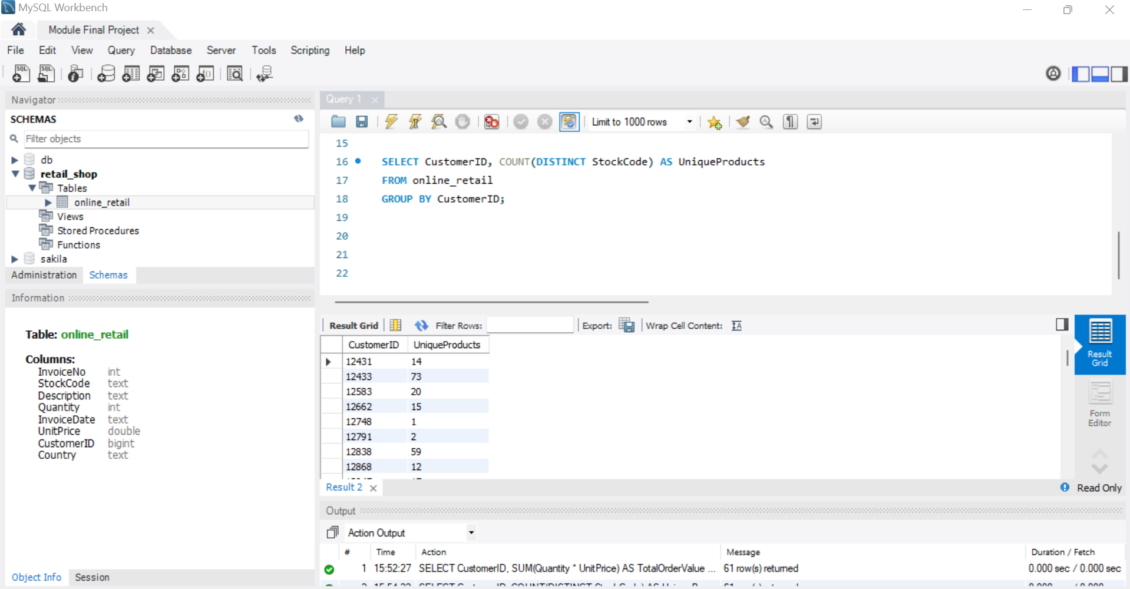

**Single Purchase Customers**

**Query:**

SELECT CustomerID

FROM online_retail

GROUP BY CustomerID

HAVING COUNT(InvoiceNo) = 1;

**Explanation:**

Identifying customers who have made only a single purchase can help in designing targeted retention strategies.

**Output:**

**Commonly Purchased Products Together**

**Query:**

SELECT A.StockCode AS Product1, B.StockCode AS Product2, COUNT(*)

AS TimesPurchasedTogether

FROM online_retail A

JOIN online_retail B

ON A.InvoiceNo = B.InvoiceNo AND

A.StockCode <> B.StockCode

GROUP BY A.StockCode, B.StockCode

ORDER BY TimesPurchasedTogether DESC;

**Explanation:**

This query finds pairs of products that are often purchased together by customers. It helps in identifying product bundling opportunities or understanding customer buying behavior.

**Output:**

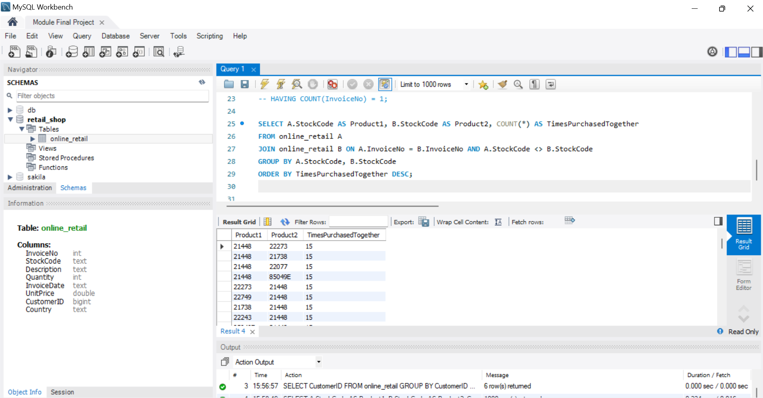

**Advance Queries**

**Customer Segmentation by Purchase Frequency**

**Query:**

SELECT CustomerID,

CASE

WHEN COUNT(InvoiceNo) > 20 THEN 'High Frequency'

WHEN COUNT(InvoiceNo) BETWEEN 10 AND 20 THEN 'Medium Frequency'

ELSE 'Low Frequency'

END AS PurchaseFrequency

FROM online_retail

GROUP BY CustomerID;

**Explanation:**

Customers are segmented based on their purchase frequency, helping identify loyal customers and those who may need more attention.

**Output:**

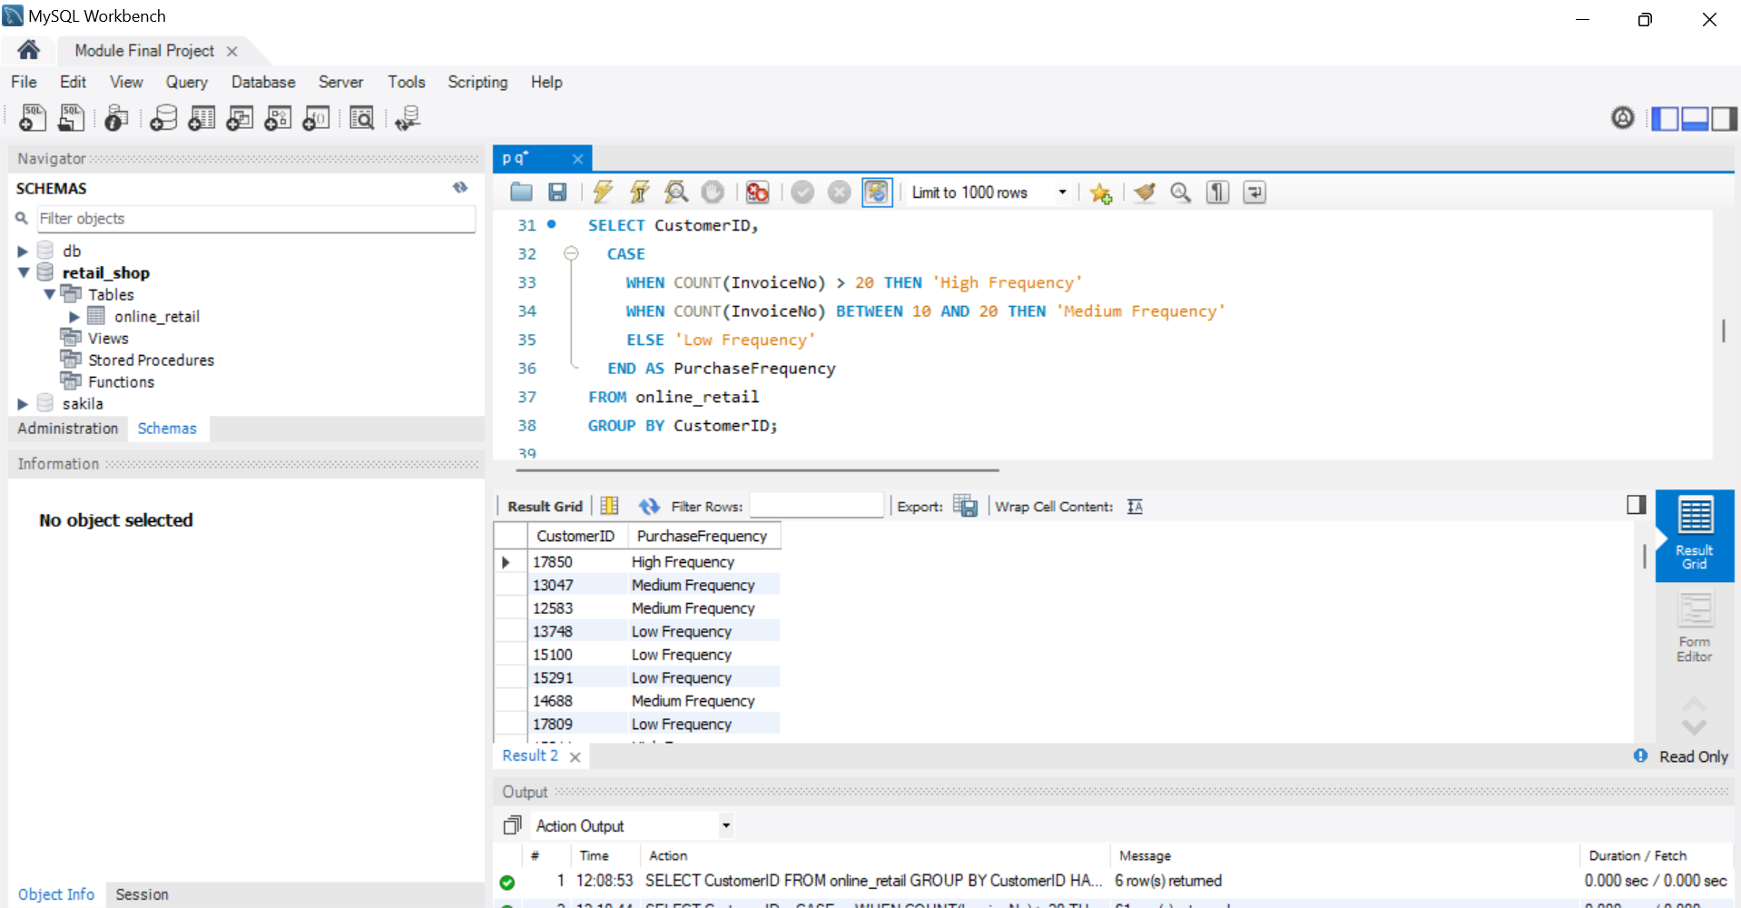

**Average Order Value by Country**

**Query:**

SELECT Country, AVG(TotalOrderValue) AS AvgOrderValue

FROM (

SELECT CustomerID, Country, SUM(Quantity * UnitPrice) AS TotalOrderValue

FROM online_retail

GROUP BY CustomerID, Country

) AS CustomerOrders

GROUP BY Country;

**Explanation:**

This query calculates the average order value by country, helping to identify regions with the highest spending customers.

**Output:**

**Customer Churn Analysis**

**Query:**

SELECT CustomerID, MAX(InvoiceDate) AS LastPurchaseDate

FROM online_retail

GROUP BY CustomerID

HAVING MAX(InvoiceDate) < DATE_SUB(CURDATE(), INTERVAL 6 MONTH);

**Explanation:**

Customers who haven't made a purchase in the last six months are identified, providing a basis for churn analysis.

**Output:**

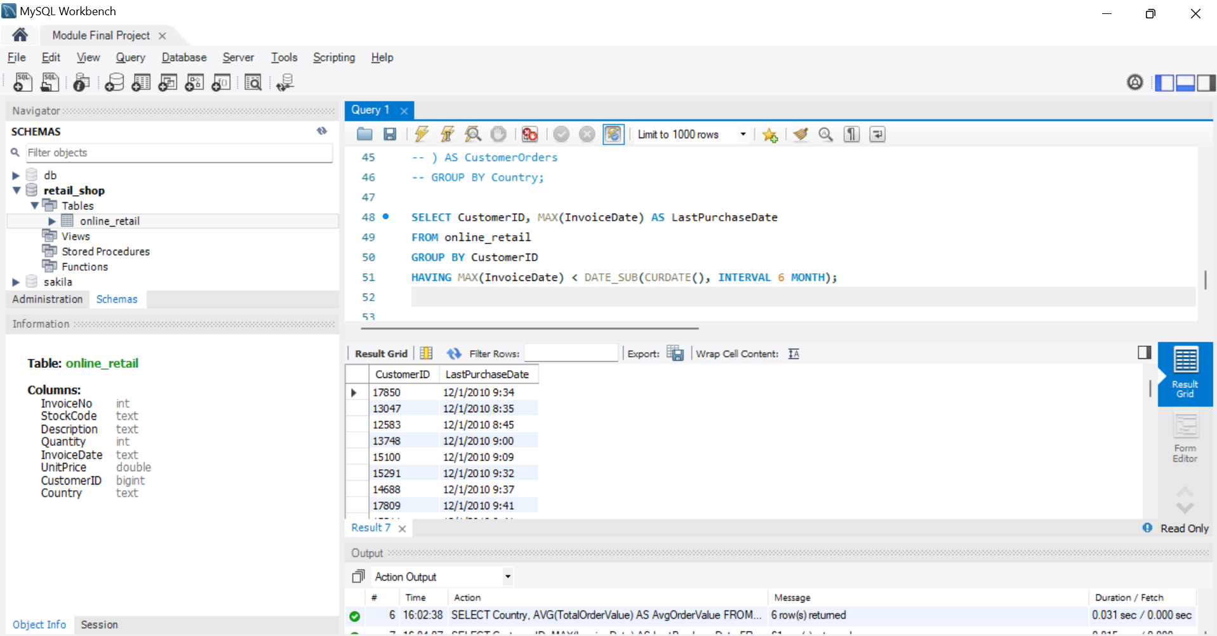

**Product Affinity Analysis**

**Query:**

SELECT A.StockCode AS Product1, B.StockCode AS Product2, COUNT(*) AS PurchaseCount

FROM online_retail A

JOIN online_retail B ON A.InvoiceNo = B.InvoiceNo AND A.StockCode <> B.StockCode

GROUP BY A.StockCode, B.StockCode

ORDER BY PurchaseCount DESC;

**Explanation:**

This analysis identifies products frequently purchased together, useful for cross-selling strategies.

**Output:**

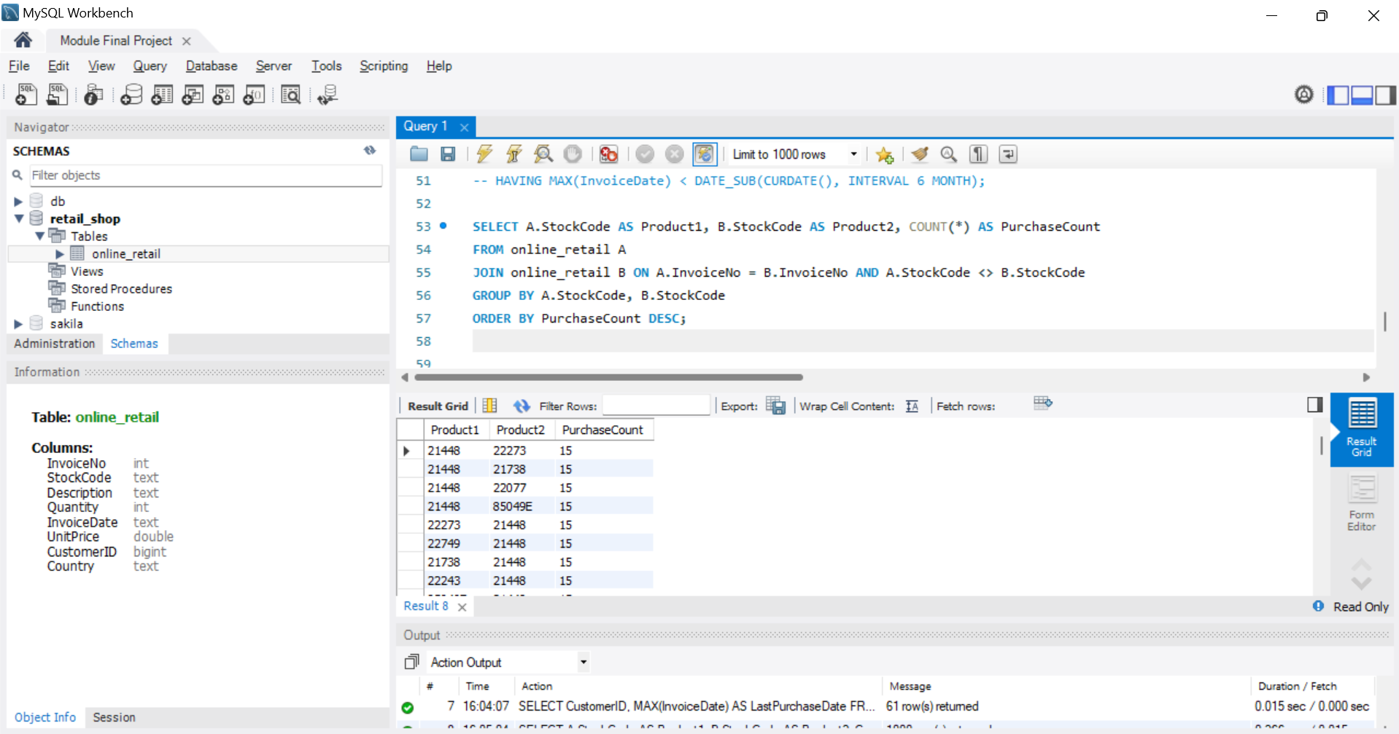

**Time-based Analysis**

**Query:**

SELECT YEAR(InvoiceDate) AS Year, MONTH(InvoiceDate) AS Month, SUM(Quantity * UnitPrice) AS MonthlySales

FROM online_retail

GROUP BY Year, Month

ORDER BY Year, Month;

**Explanation:**

Monthly sales trends are explored to understand seasonal or temporal patterns in customer behavior.

**Output:**

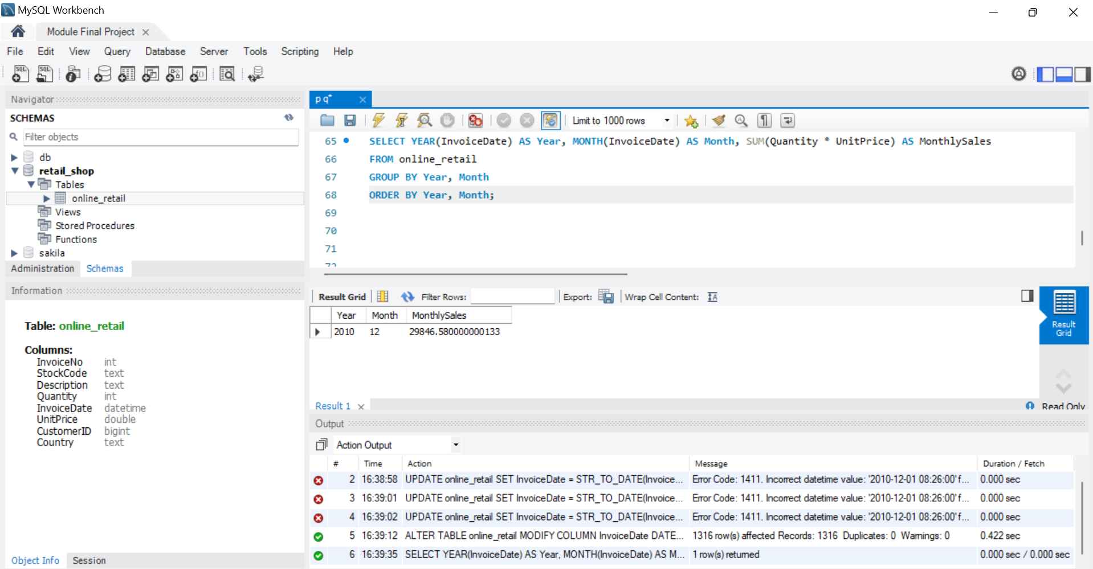

**Conclusion**

The SQL queries executed in this project provided valuable insights into customer segmentation, purchase behaviors, and potential strategies for improving customer engagement and retention. By leveraging these insights, businesses can better tailor their marketing efforts and improve overall business performance.